## Front End Engineering-II

Project Report

Semester-IV (Batch-2022)

Title of the Project: Template(36)



**Supervised By: Submitted By:**

Raveesh Samkaria Name:Suraj Adde

Roll no: 2210990876

Group: G-13

**Department of Computer Science and Engineering**

## Chitkara University Institute of Engineering & Technology,

## Chitkara University, Punjab

**CONTENTS:**

|  |  |  |
| --- | --- | --- |
| **S.NO** | **CONTENT** | **PAGE.NO** |
| **1** | **Abstract** | **1-2** |
| **2** | **Introduction** | **2** |
| **3** | **Problem Definition and Requirements** | **3** |
| **4** | **Proposed design** | **4-6** |
| **5** | **HTML code** | **7-11** |
| **6** | **CSS code** | **11-19** |
| **7** | **Result** | **20-29** |

**Abstract:**

HTML (Hypertext Markup Language) and CSS (Cascading Style Sheets) serve as the foundation of web development.

**HTML (Hypertext Markup Language)** stands as the primary markup language for crafting web pages and web applications. Let’s delve into the meaning of HTML:

**Hyper Text**: The term "hyper-text" denotes text within text. When a portion of text includes a hyperlink, it transforms into hypertext. Clicking on a link directs you to a new webpage, constituting hypertext. Essentially, hypertext facilitates linking different web pages (which are HTML documents) together.

**Markup Language**: A markup language is a computer language employed to implement layout and formatting conventions to a text document. It enhances text interactivity and dynamism. With HTML, you can transform plain text into images, tables, links, and more.

**Web Page**: A web page is a document typically authored in HTML and interpreted by a web browser. You can recognize a web page by inputting its URL. Web pages may be static or dynamic. HTML enables us to craft static web pages that exhibit nicely in web browsers.

**Let’s dissect the components:**

**<!DOCTYPE>:** Specifies the document type or provides instructions to the browser regarding the HTML version.

**<html>:** Notifies the browser of an HTML document. The content enclosed within the <html> tags delineates the web document.

**<head>:** Houses metadata (details about the document) and should be the foremost element within <html>.

**<title>**: Inserts the title of the HTML page (visible at the top of the browser window).

**<body>:** Houses the primary content visible to the end user.

**CSS (Cascading Style Sheets)** emerges as a fundamental technology in web development. Let’s delve into the essence of CSS:

**Definition**:

**CSS** serves as a **style sheet** language delineating how HTML elements ought to be **presented** and **styled** across various media, encompassing screens, paper, and other devices. It collaborates with HTML and JavaScript to craft visually captivating and well-organized web pages.

**Key Points**:

**Presentation and Styling**: CSS dictates the visual representation of web content, encompassing elements like fonts, colors, spacing, layout, and positioning.

**Cascading**: The concept of "cascading" denotes the sequence in which styles are applied. Multiple styles can coexist, with the most specific rule taking precedence.

**Stylesheets**: CSS rules typically reside in external .css files. These files encapsulate style definitions reusable across multiple web pages.

**Efficiency**: Utilizing CSS enables the maintenance of a consistent appearance throughout an entire website sans code duplication.

**Introduction:**

**Background:** Provide contextual information regarding the project, elucidating its relevance and necessity.

**Objectives:** Explicitly outline the project's goals and objectives.

**Significance:** Expound upon the project's importance and potential impact.

**Problem Definition and Requirements**

**Problem Statement**: Describe the specific problem or challenge addressed by the project.

**Software Requirements**: List the software tools, libraries, and technologies used.

**Text Editors / Integrated Development Environments (IDEs**): Visual Studio Code (VS Code): A widely used free code editor renowned for its excellent support for HTML and CSS.

**Browser Extensions:** Live Server: Facilitates instant reloading of HTML and CSS changes. CSS Viewer: Allows inspection of CSS properties on any webpage.

**Hardware Requirements:** Specify any hardware components required for the project.

**Web Browser:** Install popular web browsers for testing your HTML and CSS: Google Chrome

**Text Editor or IDE:** Select a text editor or integrated development environment (IDE) for writing code: Visual Studio Code (VS Code)

**Proposed Design / Methodology:**

**Design:**

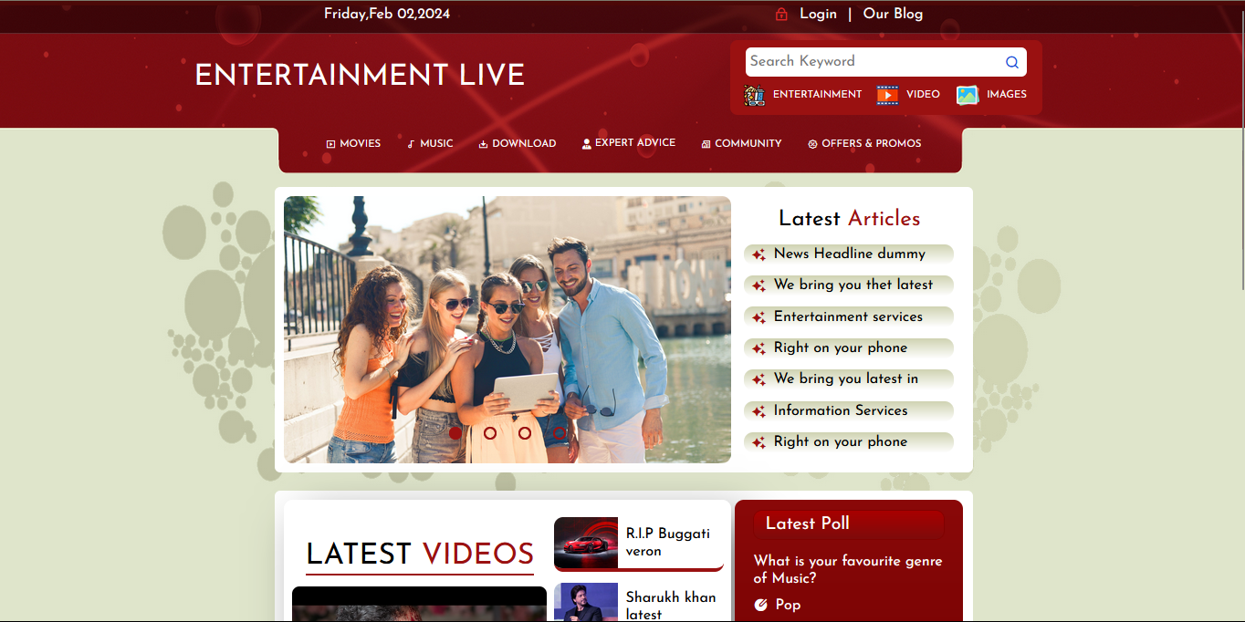

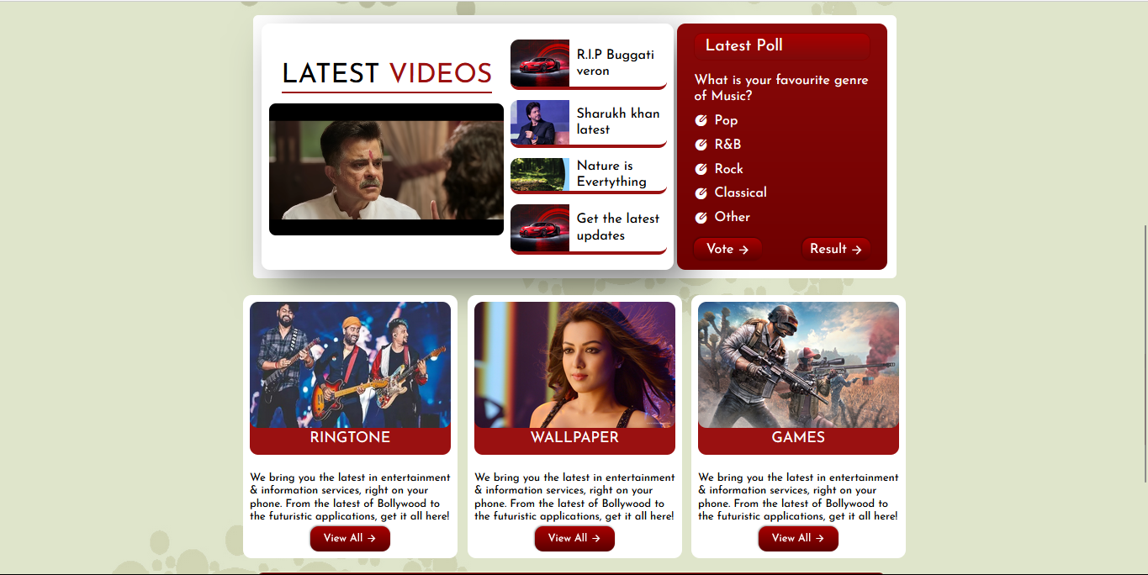

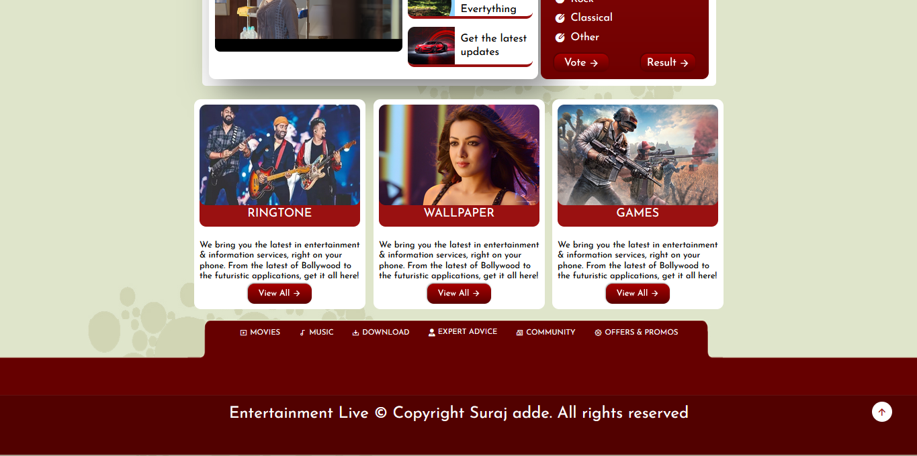

**Source code:**

**HTML CODE:**

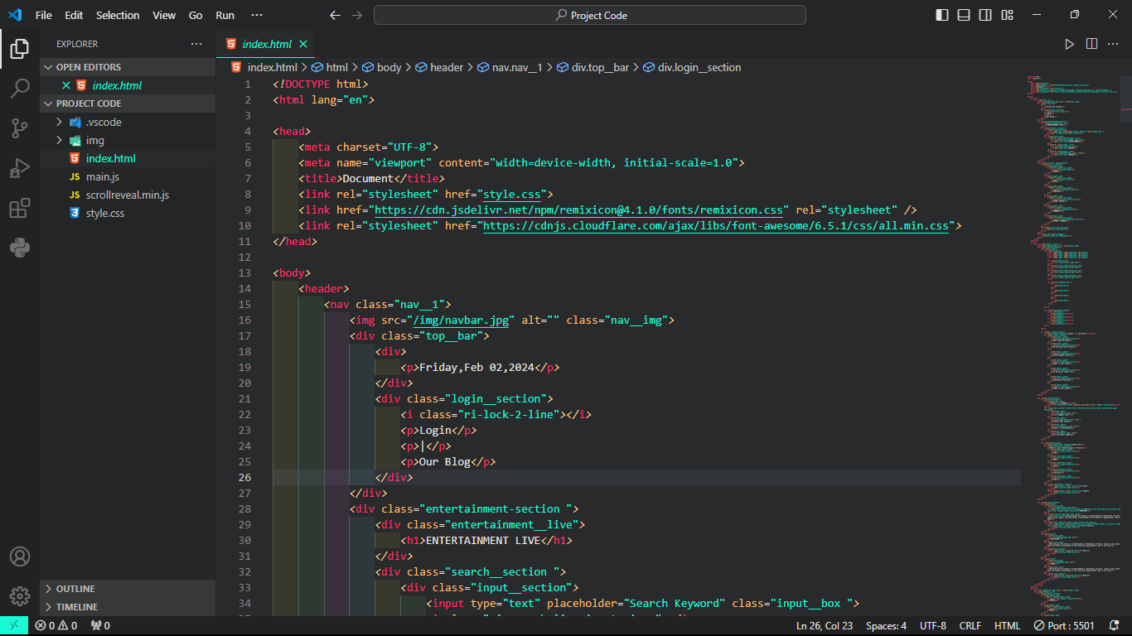

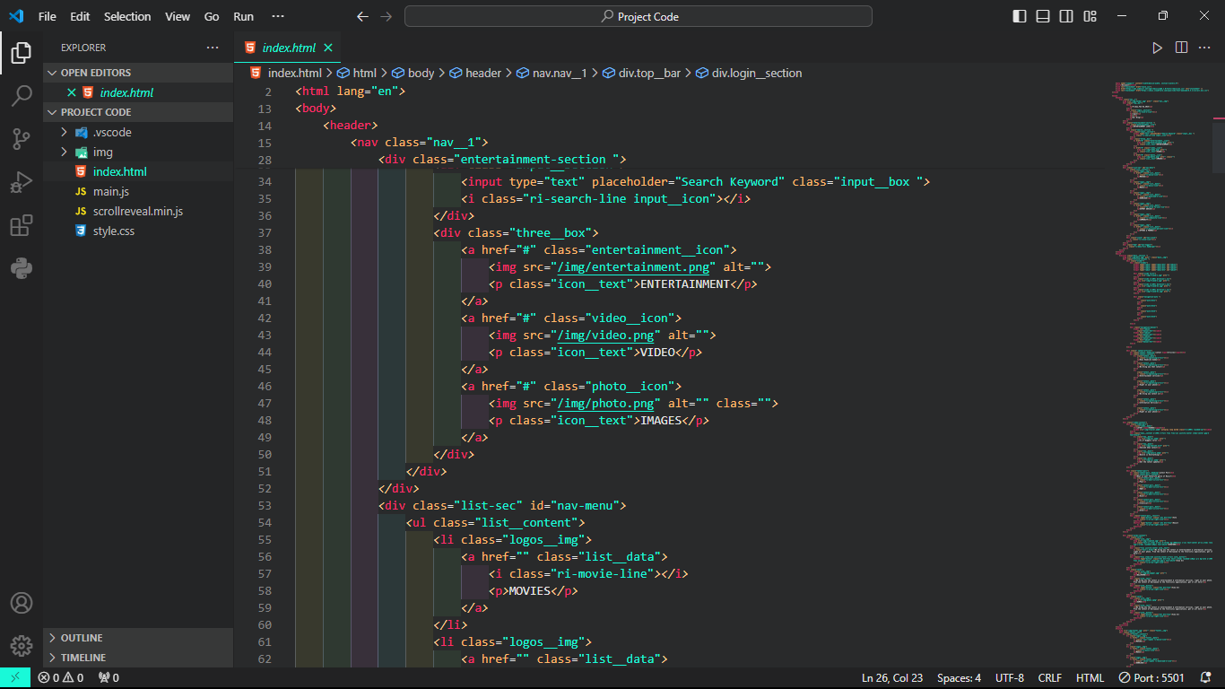

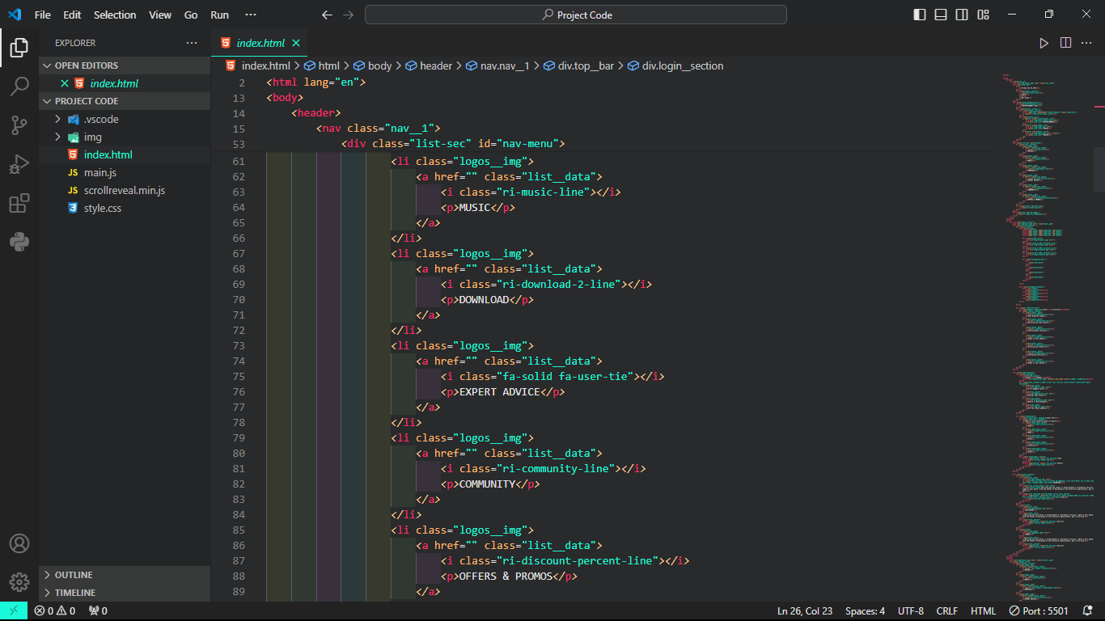

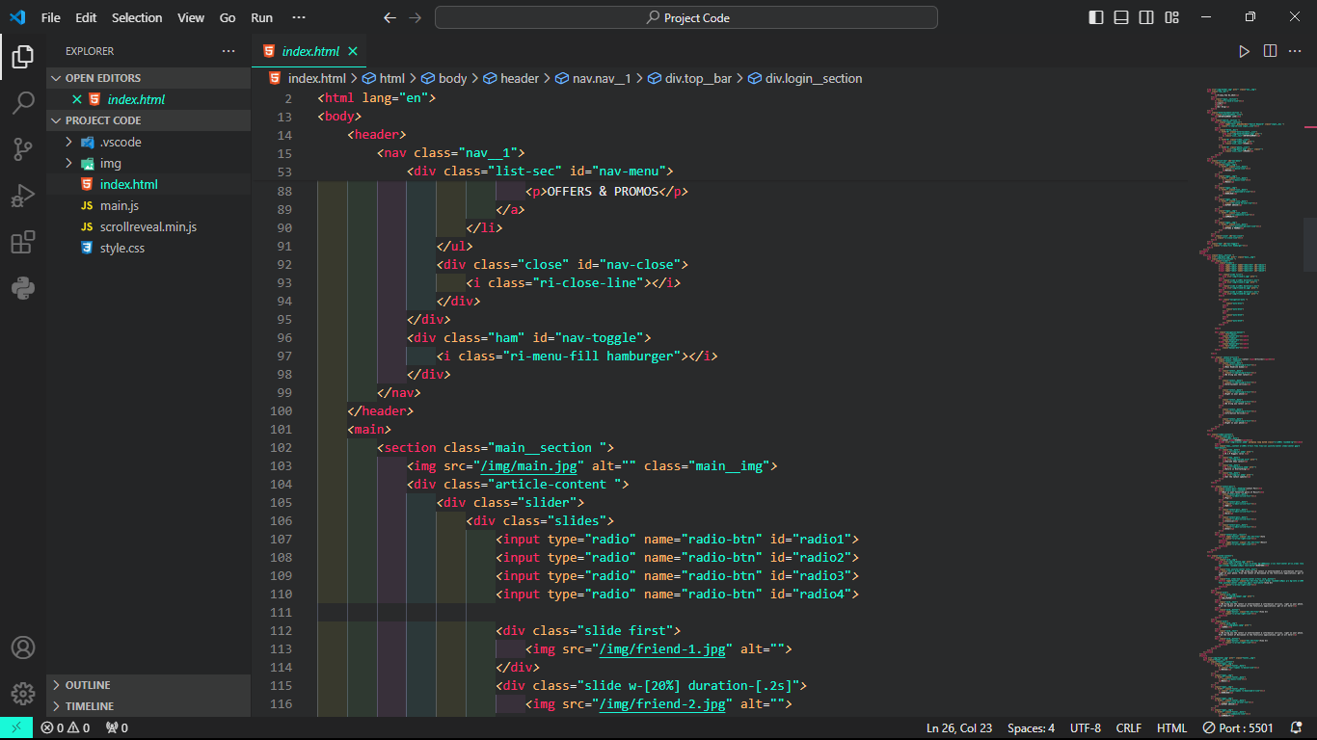

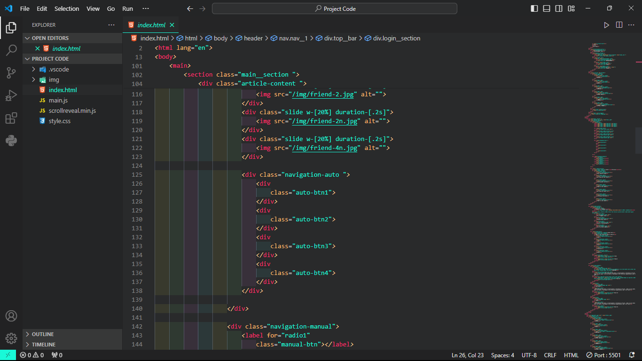

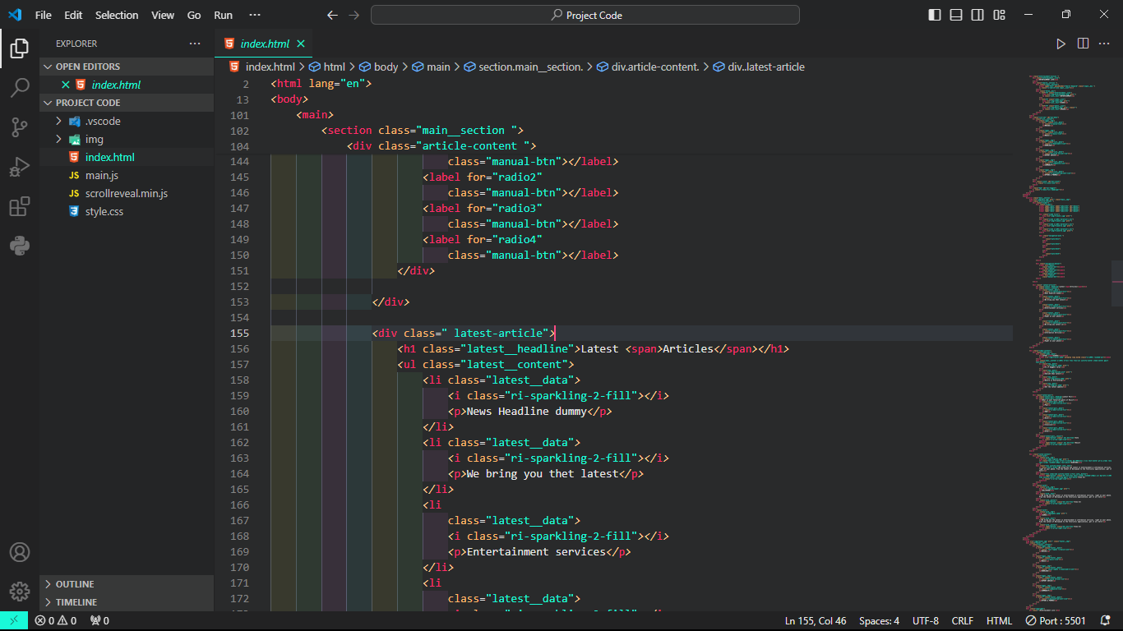

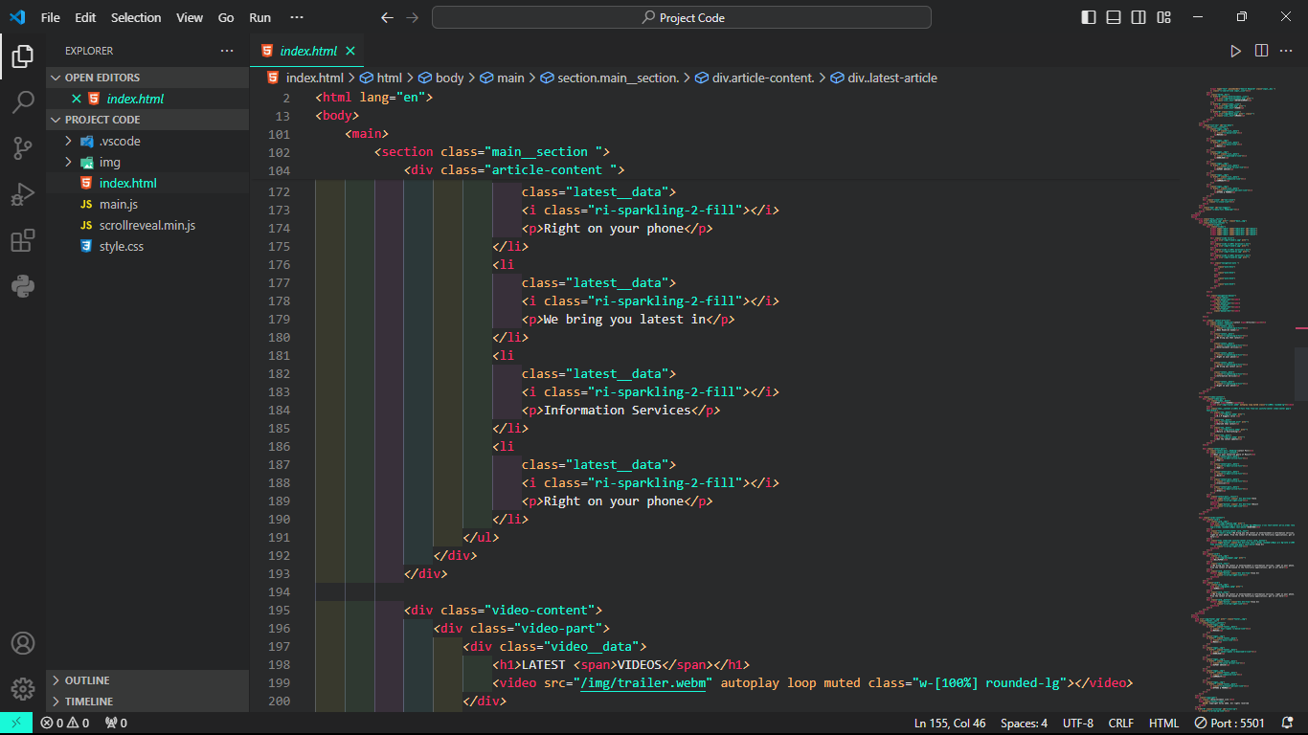

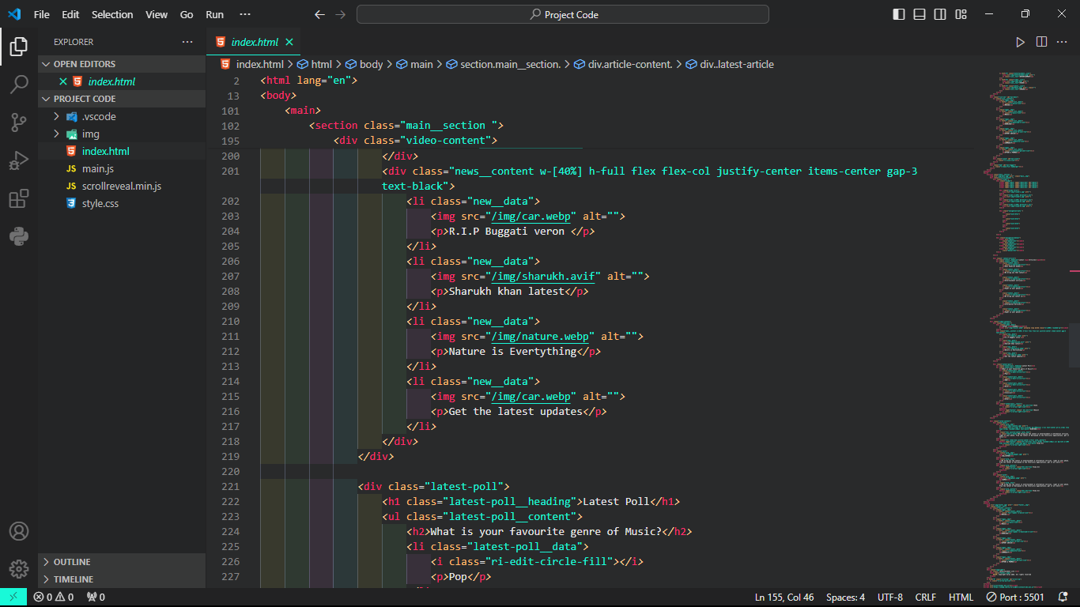

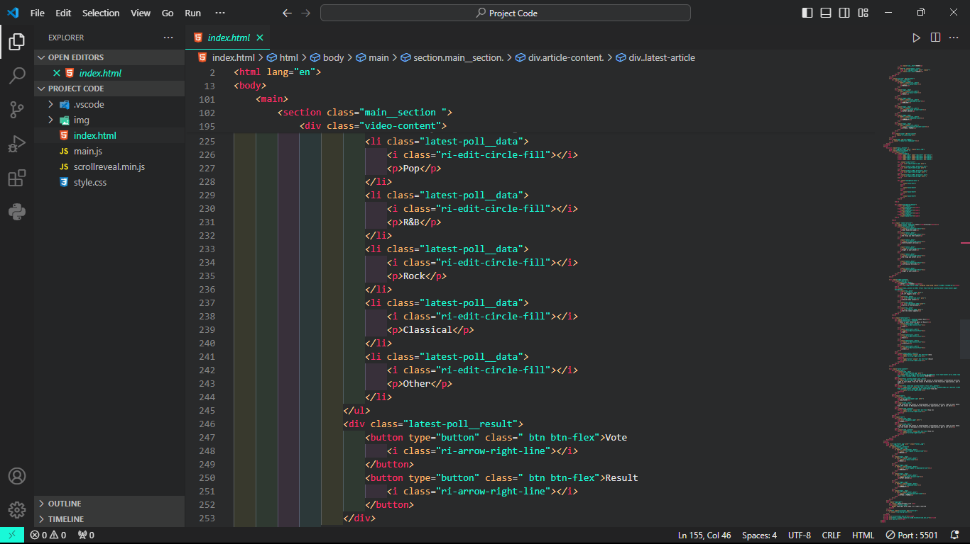

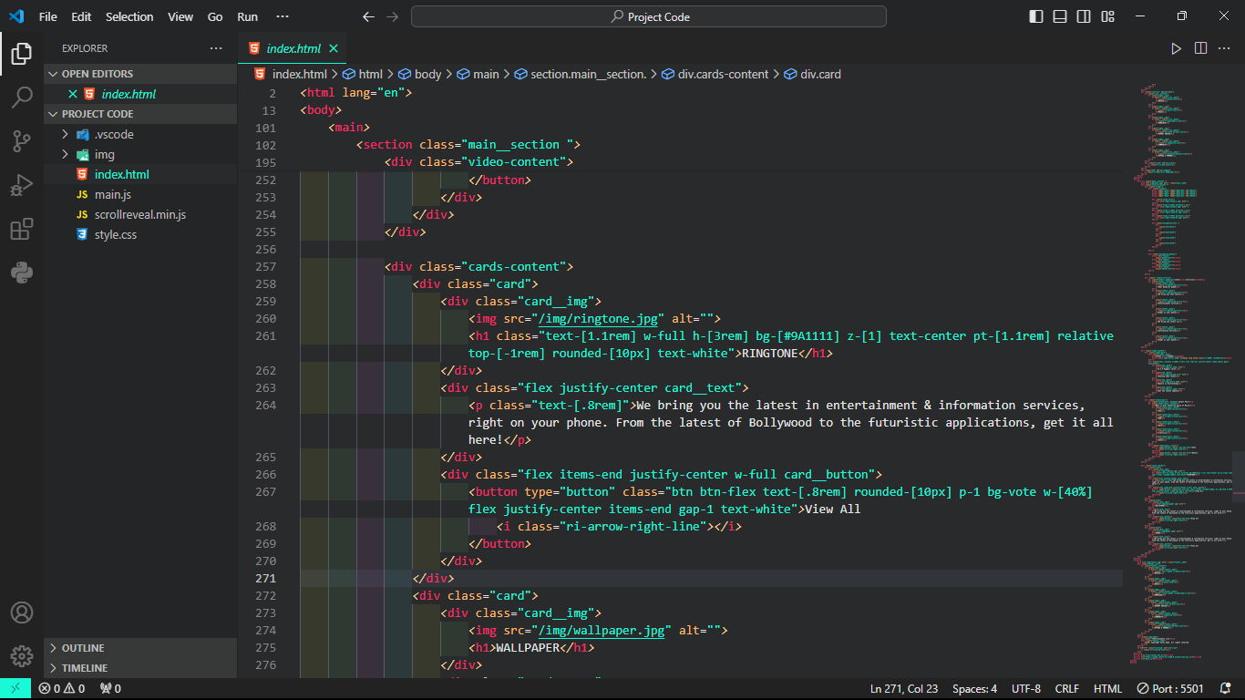

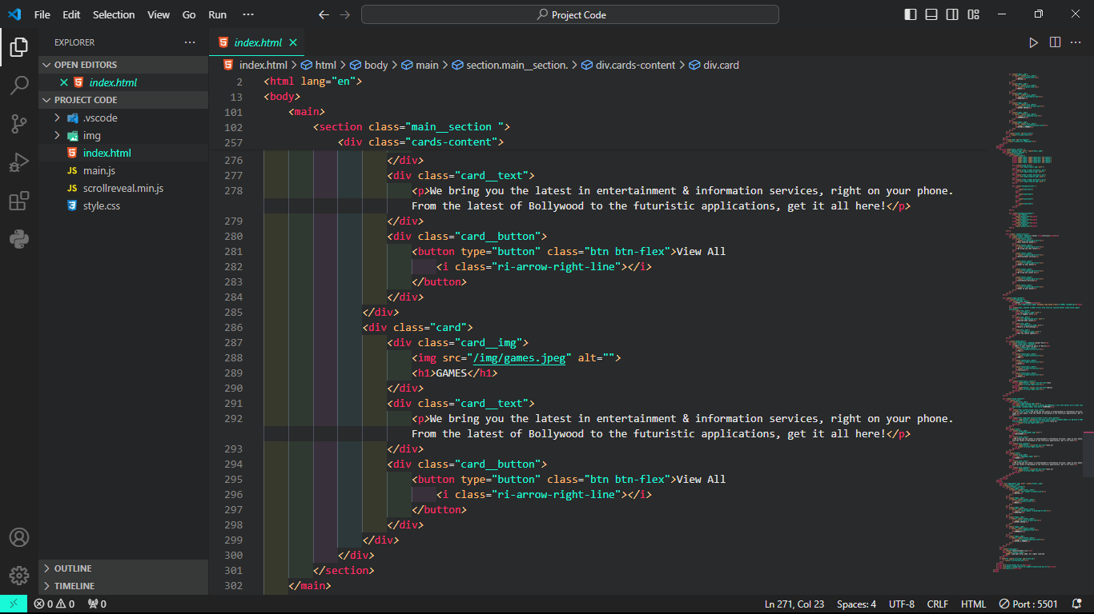

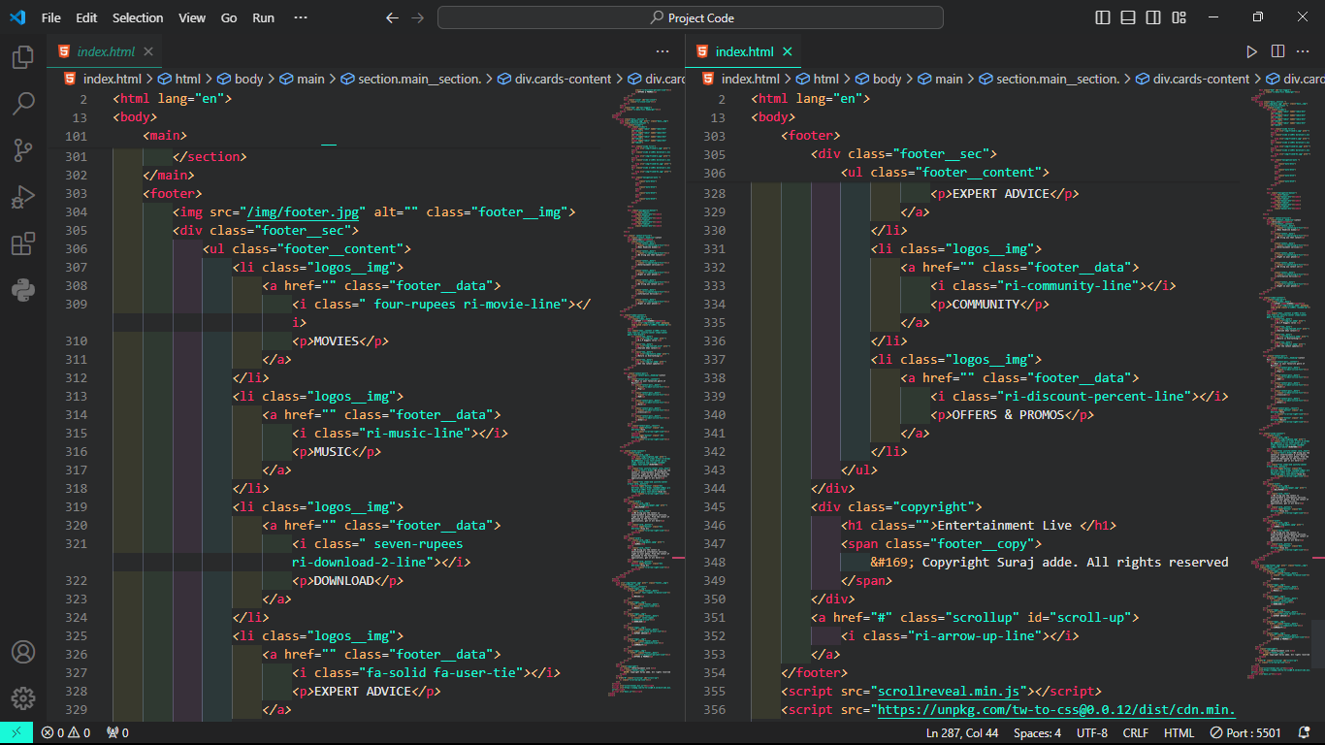

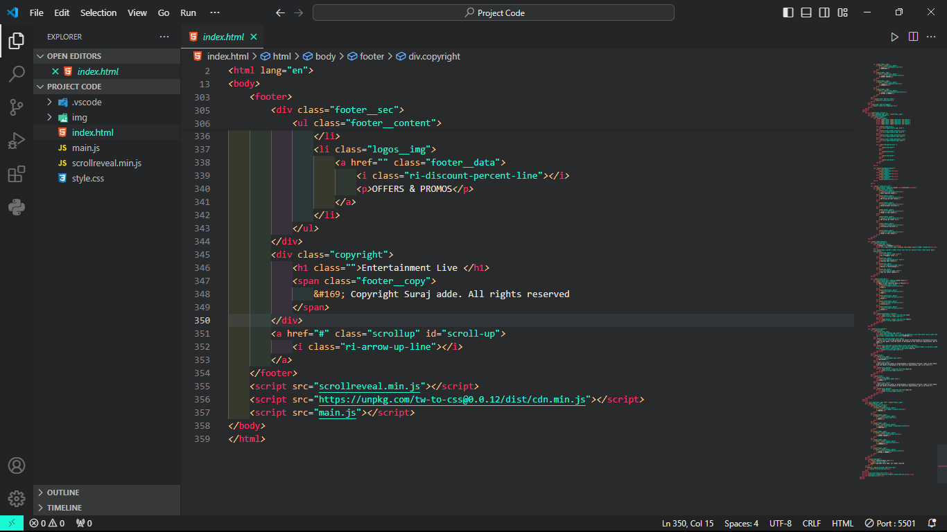

**CSS CODE: DESKTOP**

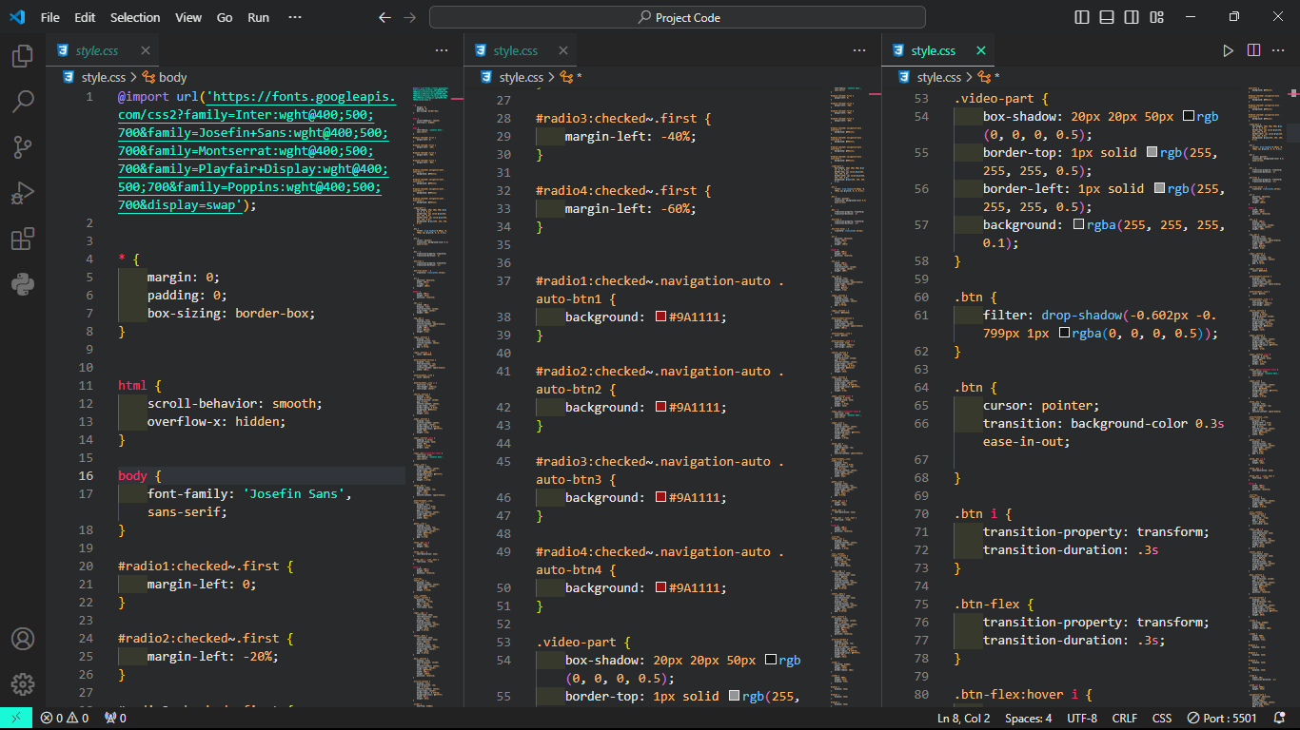

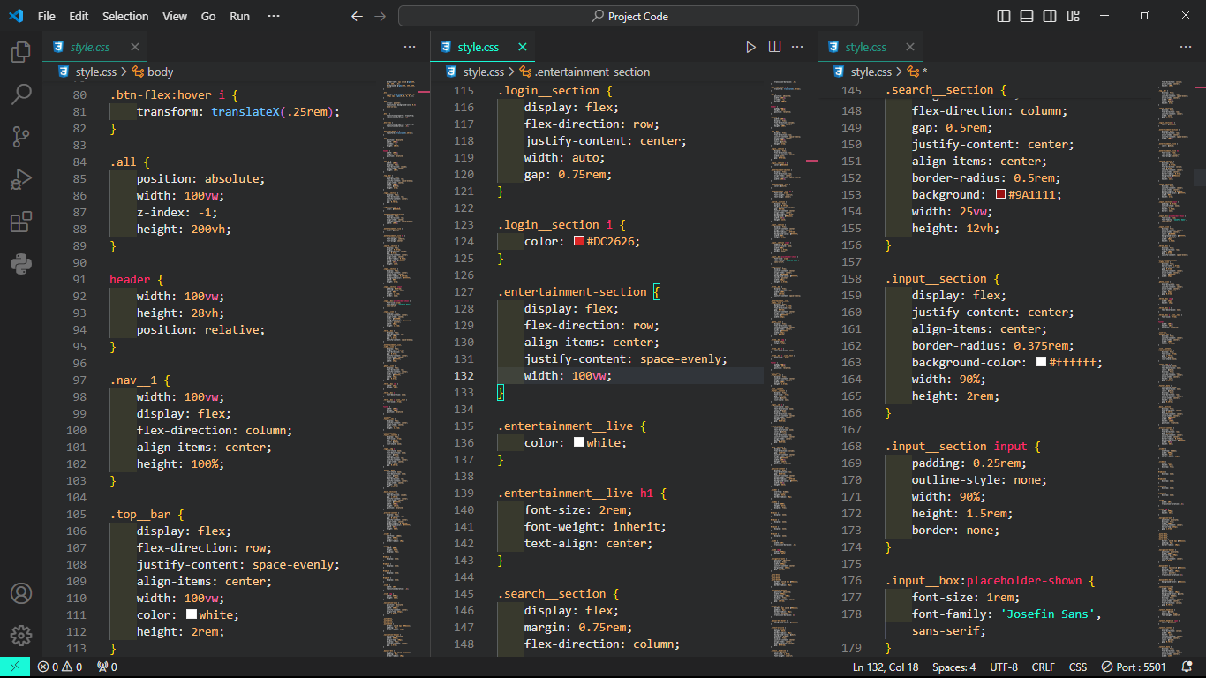

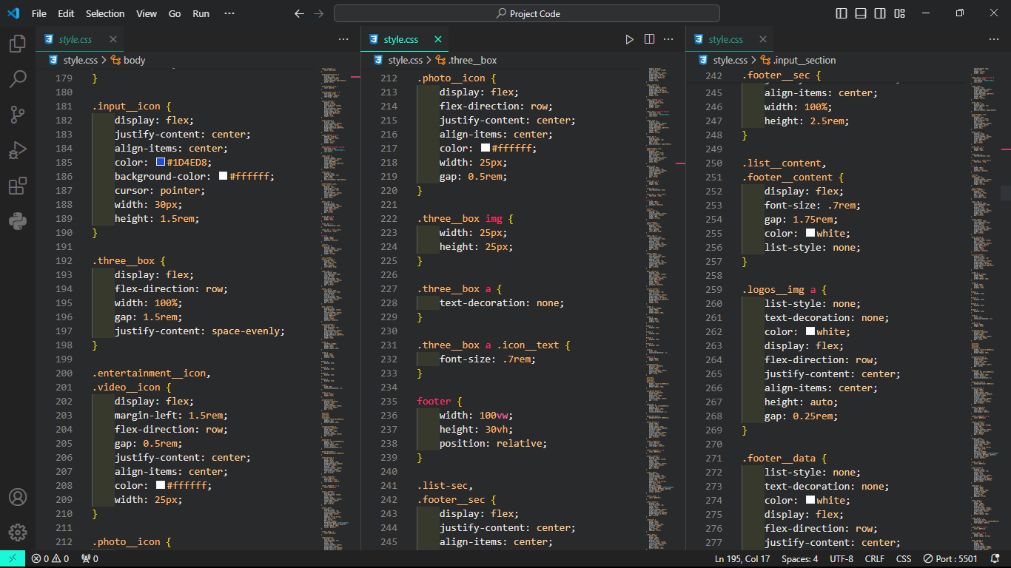

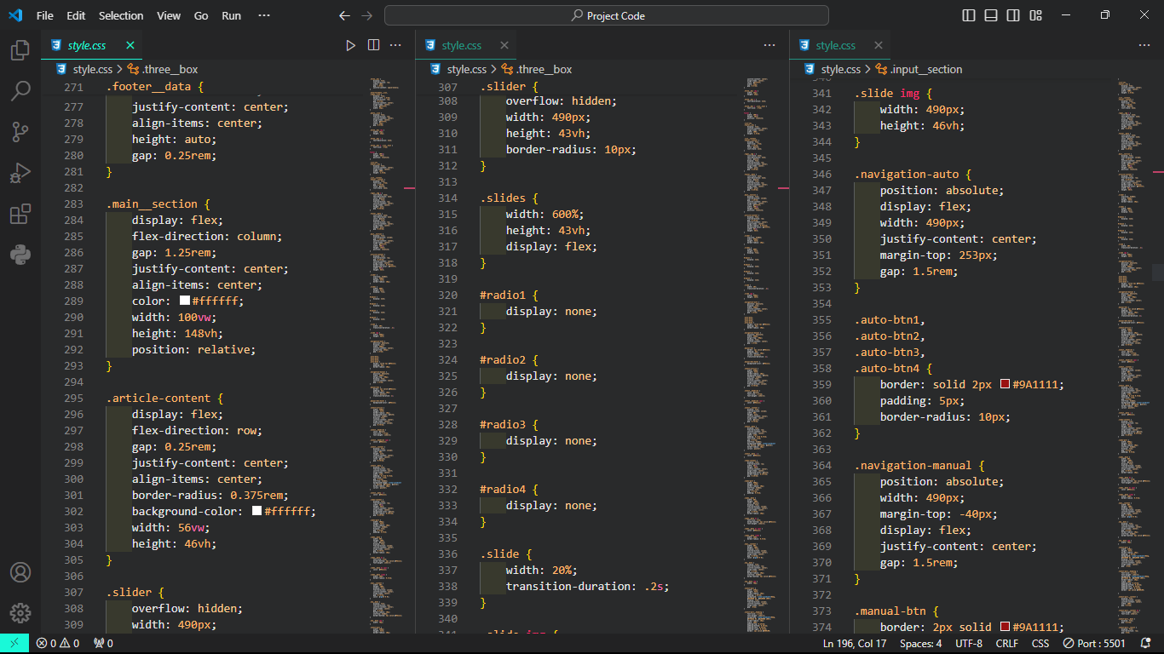

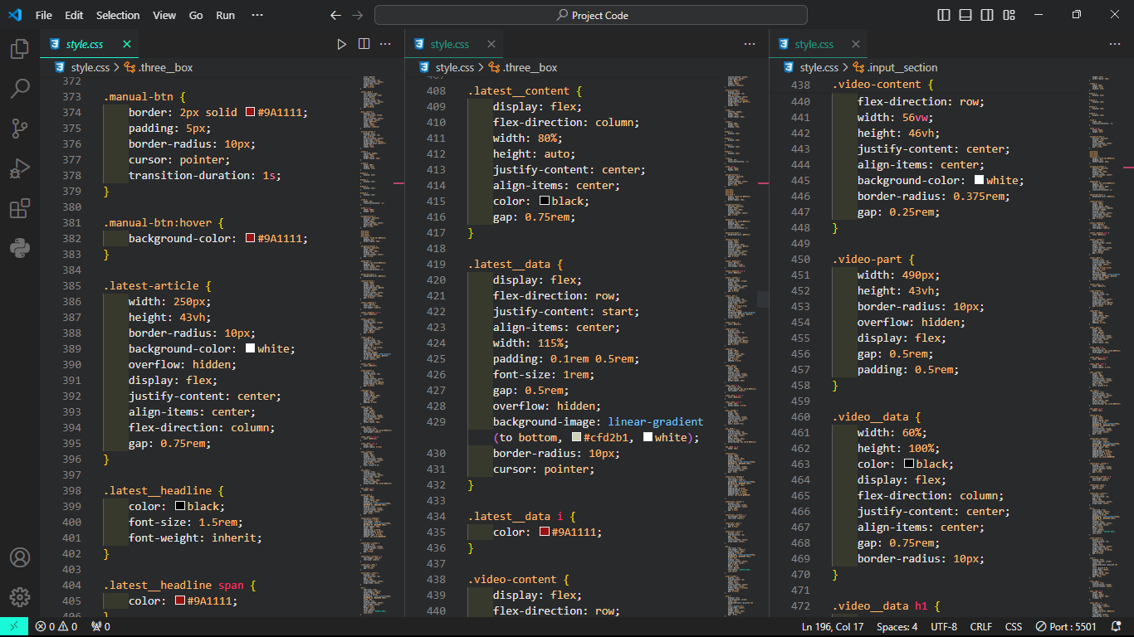

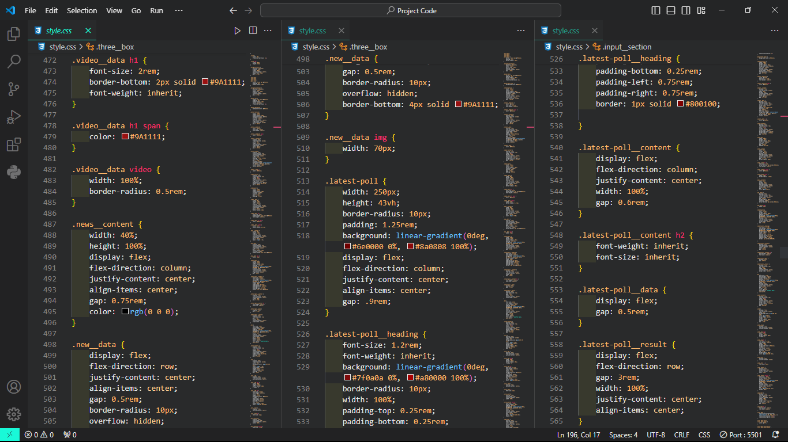

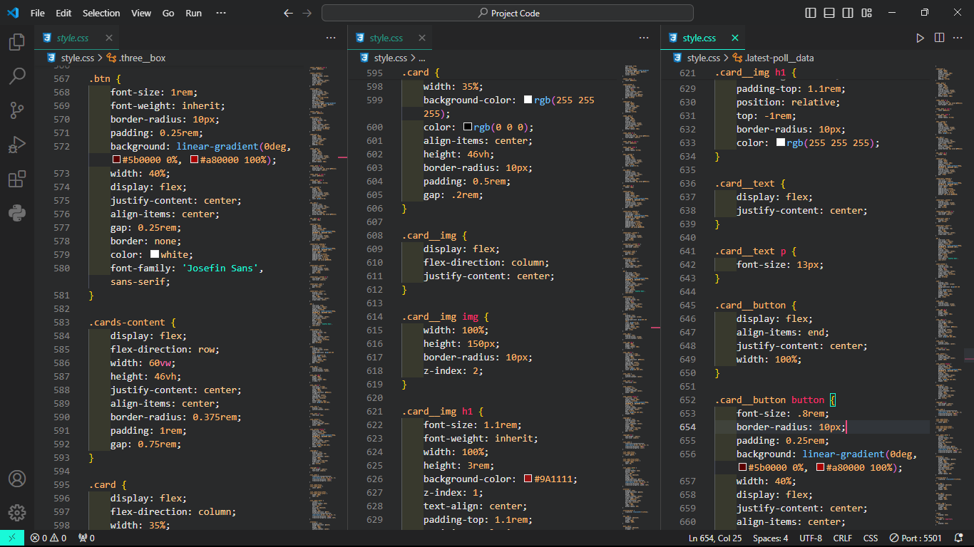

**CSS CODE : FOR MAX WIDTH:500**

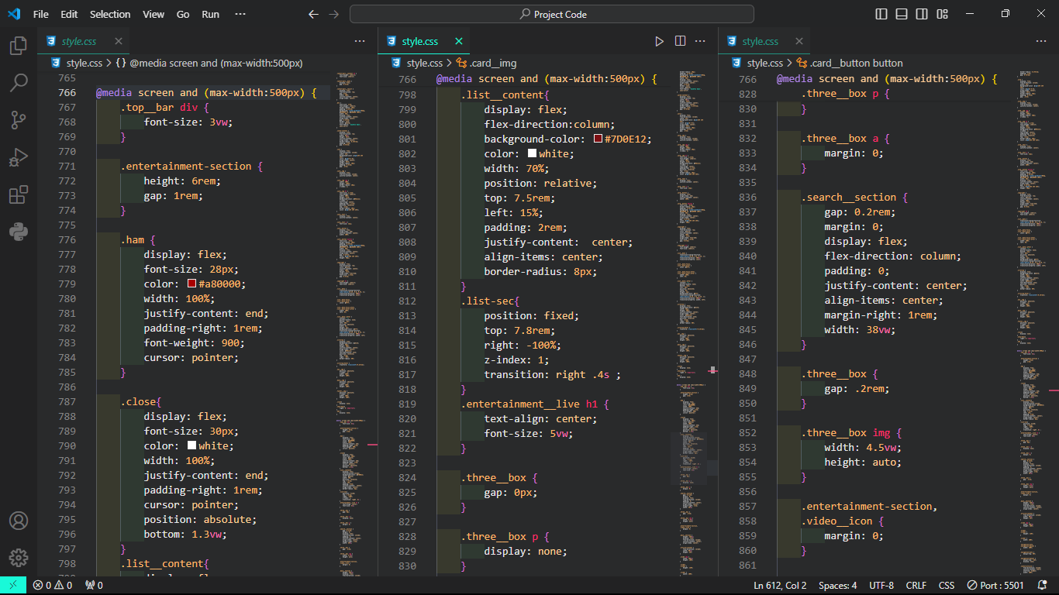

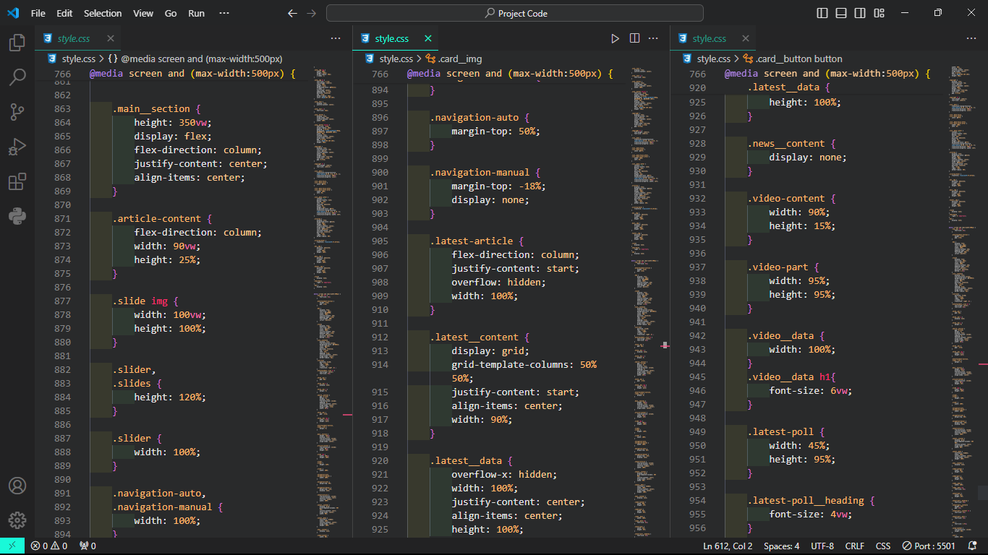

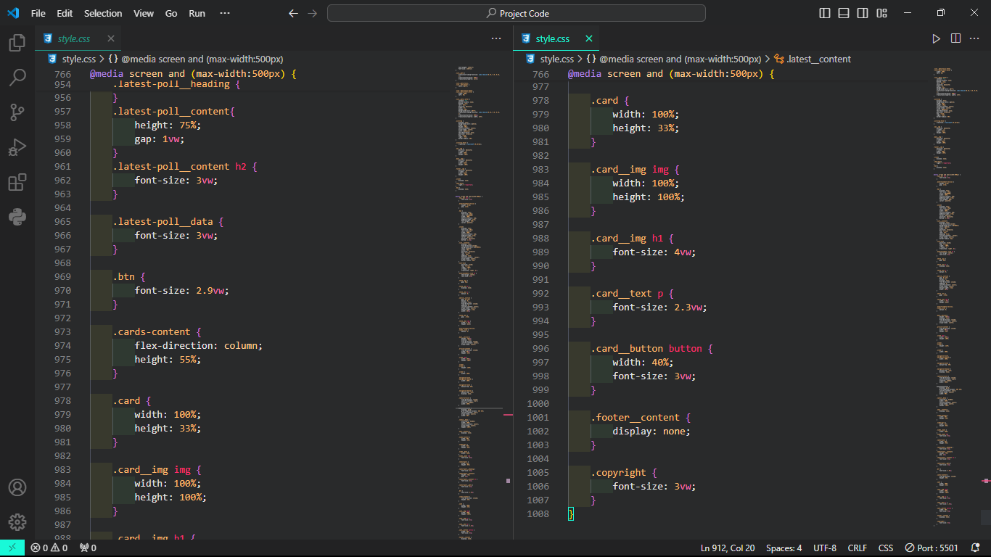

**RESULT:**

**DESKTOP**







**FOR MAX WIDTH:500**

